Week 3 Report: Advanced Data Analysis and Visualization in Logistics
Prepared by: Sarnadip | Logistics Data Analyst Intern | Week 3

1. Introduction and Dataset Description
This report explores a logistics dataset in depth and uses charts to find what drives delivery delays and delivery cost. It follows four steps: describe the data, calculate summary numbers, draw charts that answer specific questions, and turn the findings into recommendations. Every claim in the report is supported by a number from the data.
Dataset. The analysis uses the cleaned file from Week 2 (Delivery_Logistics_Cleaned.csv). It comes from the public Kaggle dataset "Delivery Logistics Dataset (India – Multi-Partner)" by kundanbedmutha and holds 25,000 deliveries and 14 columns. The data is described here as if it came from a company's delivery system.
Group | Variables | Used for
Delivery times | delivery_time_hours (actual), expected_time_hours (promised) | Efficiency and bottlenecks
Shipment size | package_weight_kg (the dataset has no shipment counts, so weight is used as the measure of shipment size) | Cost drivers
Transport cost | delivery_cost (₹), distance_km | Cost drivers
Delivery setup | delivery_partner (9), vehicle_type (6), delivery_mode (4), region (5), package_type (9) | Comparing groups
Conditions | weather_condition (6) | External causes of delay
Results | delayed, delivery_status, delivery_rating (1 to 5) | Performance and customer impact

2. Background: Why Data Visualization Matters in Logistics
From numbers to decisions. Logistics data has many moving parts: routes, vehicles, partners, weather and customers. Industry sources describe data visualization as turning this complex data into charts that managers can understand quickly, so they can find bottlenecks and improve decisions. Typical measures shown in this way include on-time delivery rates, average transit times and the common causes of delays.
Dashboards and weather. Logistics dashboards bring delivery times, cost per shipment and similar measures into one view, so managers can judge performance at a glance. Sources also describe dashboards that follow weather, traffic and delivery schedules to warn managers about disruptions, and that compare vendors by on-time rate and cost. The last mile, the final step to the customer, is described as the most complex and costly stage, which is why delivery data is worth visualizing.
Why the chart type matters. Each chart type answers a different question. A histogram shows how values are spread, a bar chart compares groups, a grouped bar chart compares two measures side by side, and a heatmap shows many combinations at once. A wrong choice can hide a pattern. For example, in this dataset a table of overall averages hides that express deliveries in stormy weather are late 99.8% of the time, while one heatmap shows it immediately (Section 4.5).
Tools. The charts in this report are made with Python: pandas for calculations, and matplotlib and seaborn for drawing.

3. Exploratory Data Analysis

3.1 Summary statistics (central tendencies)
import pandas as pd
df = pd.read_csv("Delivery_Logistics_Cleaned.csv")
print("Rows and columns:", df.shape)
columns = ["distance_km", "package_weight_kg", "delivery_time_hours",
"expected_time_hours", "delivery_cost", "delivery_rating"]
summary = df[columns].agg(["mean", "median", "std", "min", "max"]).round(1)
print(summary)
Result:
Column | Mean | Median | Std | Min | Max
distance_km | 150.4 | 151.0 | 86.4 | 3.6 | 297.1
package_weight_kg | 25.1 | 25.1 | 14.4 | 0.7 | 49.5
delivery_time_hours | 6.2 | 6.0 | 3.1 | 0 | 19
expected_time_hours | 13.1 | 8.0 | 7.6 | 2 | 24
delivery_cost | 864.9 | 867.5 | 435.7 | 95.7 | 1,632.7
delivery_rating | 3.7 | 4.0 | 1.1 | 1 | 5
Insight:
- Distance, weight and cost have a mean very close to the median (for example, 150.4 vs 151.0 km), so their values are spread evenly with no heavy skew.
- Expected time has a mean of 13.1 hours but a median of only 8.0, so a group of deliveries with long promised times pulls the average up.
- The average delivery takes 6.2 hours against 13.1 promised, which looks fine on average but hides the 26.7% of deliveries that are still late. Averages alone are not enough, so the next sections compare groups.
- The average rating (3.7) is below the median (4.0), so a number of low ratings pull the average down.

4. Visualizations and Insights
Each part below gives the reason for the chart, the code, the result and the insight. Insert the screenshot of each chart where indicated.

4.1 Distributions (histograms)
Why this chart: A histogram shows how values are spread across ranges, which helps spot skew, gaps and unusual peaks in operational data.
import matplotlib.pyplot as plt
import seaborn as sns
fig, axes = plt.subplots(1, 3, figsize=(15, 4))
sns.histplot(df["distance_km"], bins=30, ax=axes[0], color="steelblue")
axes[0].set_title("Distance (km)")
sns.histplot(df["delivery_cost"], bins=30, ax=axes[1], color="seagreen")
axes[1].set_title("Delivery Cost")
sns.histplot(df["delivery_time_hours"], bins=20, ax=axes[2], color="darkorange")
axes[2].set_title("Delivery Time (hours)")
plt.tight_layout()
plt.show()
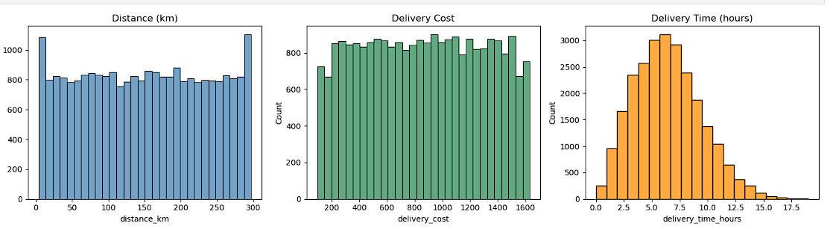
Result:
Variable | Shape | What it shows
Distance (km) | Almost flat, about 800 deliveries in most bars | Deliveries are spread evenly from 4 to 297 km, with slightly taller bars at the shortest and longest ends (about 1,100 each)
Delivery cost | Almost flat from about ₹200 to ₹1,550 | Costs are spread evenly, with fewer deliveries in the lowest and highest cost bars
Delivery time (hours) | Bell shape with a longer tail on the right | Most deliveries take 5 to 8 hours, the peak is at about 6 to 7 hours (about 3,100 deliveries), and a few take up to 19 hours
Insight:
- Distance and cost have the same flat shape, which matches the finding that cost is almost fully decided by distance (correlation 0.99).
- The company serves short, medium and long distances in similar numbers, so no single distance band dominates its workload.
- Delivery time is bunched around the 6-hour mark, but the right tail shows a small group of deliveries taking 12 to 19 hours. These slow deliveries are the first place to look for bottlenecks.

4.2 Actual vs expected time by delivery mode
Why this chart: A grouped bar chart puts two numbers side by side for each category, so the gap between what was promised and what was delivered is easy to see.
time_by_mode = df.groupby("delivery_mode")[["delivery_time_hours", "expected_time_hours"]].mean().round(1)
print(time_by_mode)
time_by_mode.plot(kind="bar", figsize=(8, 5), color=["darkorange", "steelblue"])
plt.title("Actual vs Expected Delivery Time by Mode")
plt.ylabel("Hours")
plt.xlabel("Delivery mode")
plt.xticks(rotation=0)
plt.legend(["Actual time", "Expected time"])
plt.show()
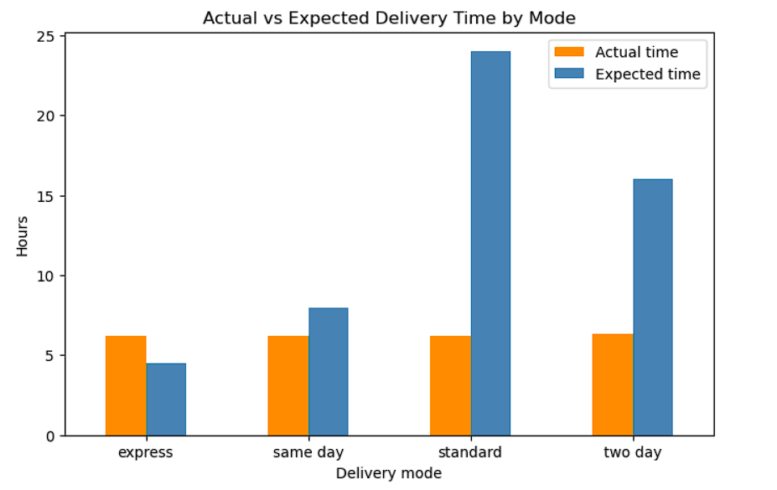
Result:
Delivery mode | Actual time (hours) | Expected time (hours) | Gap
Express | 6.2 | 4.5 | 1.7 hours slower than promised
Same day | 6.2 | 8.0 | 1.8 hours faster than promised
Standard | 6.2 | 24.0 | 17.8 hours faster than promised
Two day | 6.3 | 16.0 | 9.7 hours faster than promised
Insight:
- Every mode takes about 6.2 hours, so the "faster" modes are not actually faster. Only the promise is different.
- Express is the one mode where the actual time (6.2 hours) is longer than the promise (4.5 hours), which explains why 73.8% of express deliveries are late.
- Same day is faster than its promise on average (6.2 vs 8.0 hours), yet 32.5% are still late. Some deliveries run much longer than the average, which matches the right tail seen in the histogram.
- Standard and two day have a very large buffer (17.8 and 9.7 hours), which is why they are almost never late.
- The bottleneck is mainly in how the promises are set, not in how fast the deliveries are made.

4.3 Correlation heatmap
Why this chart: A heatmap shows every pair of variables in one picture, so the strongest and weakest links can be spotted at a glance. The colors make strong links stand out, and the numbers give the exact values.
columns = ["distance_km", "package_weight_kg", "delivery_time_hours",
"expected_time_hours", "delivery_cost", "delivery_rating"]
plt.figure(figsize=(8, 6))
sns.heatmap(df[columns].corr().round(2), annot=True, cmap="coolwarm", vmin=-1, vmax=1)
plt.title("Correlation Between Delivery Variables")
plt.tight_layout()
plt.show()
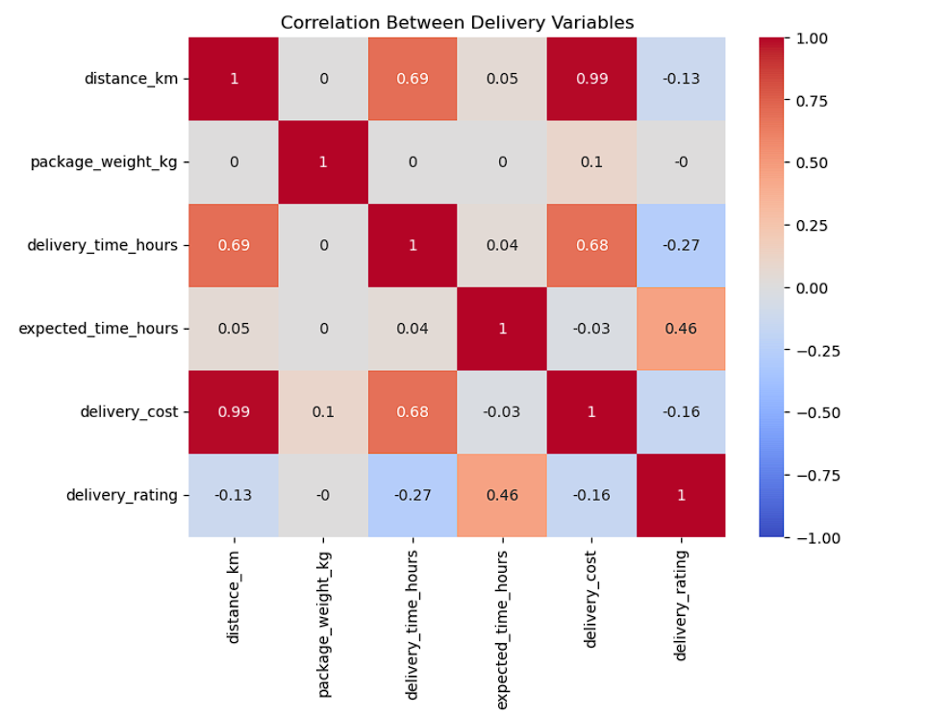
Result:
Pair of variables | Correlation | Meaning
Distance and cost | 0.99 | Cost is almost fully decided by distance
Distance and delivery time | 0.69 | Longer distances take longer
Delivery time and cost | 0.68 | Slower deliveries cost more, mainly because they are also longer in distance
Expected time and rating | 0.46 | Deliveries with a longer promised time get higher ratings
Delivery time and rating | -0.27 | Slower deliveries get lower ratings
Weight and every other variable | 0.10 or less | Package weight has almost no effect
Insight:
- Distance is the main driver of both cost (0.99) and delivery time (0.69), so route length is the first thing to manage.
- Weight has almost no link to cost (0.10) or time (0.00), so pricing by weight would not match how costs behave in this data.
- Customers rate deliveries higher when the promised time is longer (0.46), and lower when the real time is longer (-0.27). A likely reason is that deliveries with long promises are rarely late, though correlation alone does not prove this.
- Expected time and actual time are almost unrelated (0.04). Promises are not based on how long the delivery will really take, which supports the finding that the bottleneck is in how promises are set.

4.4 Delay rate by weather and vehicle type
Why this chart: Bar charts compare one value across categories, and sorting the bars from lowest to highest makes the worst group easy to see.
delay_weather = (df["delayed"] == "yes").groupby(df["weather_condition"]).mean() * 100
delay_vehicle = (df["delayed"] == "yes").groupby(df["vehicle_type"]).mean() * 100
fig, axes = plt.subplots(1, 2, figsize=(13, 5))
delay_weather.sort_values().plot(kind="bar", ax=axes[0], color="steelblue")
axes[0].set_title("Delay Rate by Weather")
axes[0].set_ylabel("Delayed deliveries (%)")
axes[0].set_xlabel("")
delay_vehicle.sort_values().plot(kind="bar", ax=axes[1], color="seagreen")
axes[1].set_title("Delay Rate by Vehicle Type")
axes[1].set_ylabel("Delayed deliveries (%)")
axes[1].set_xlabel("")
plt.tight_layout()
plt.show()
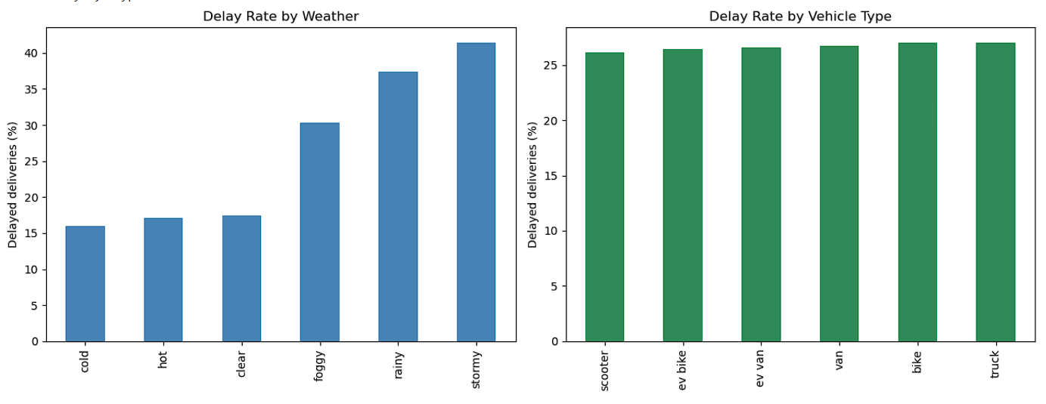
Result:
Weather | Delay rate | Vehicle type | Delay rate
Stormy | 41.4% | Bike | 27.0%
Rainy | 37.4% | Truck | 27.0%
Foggy | 30.3% | Van | 26.8%
Clear | 17.4% | EV van | 26.6%
Hot | 17.1% | EV bike | 26.4%
Cold | 16.0% | Scooter | 26.1%
Insight:
- Stormy weather has a 41.4% delay rate, about 2.4 times the 17.4% in clear weather. Rainy (37.4%) and foggy (30.3%) are also well above clear weather.
- Hot and cold weather (17.1% and 16.0%) are about the same as clear weather, so the problem is bad visibility and wet roads, not temperature.
- Vehicle type makes almost no difference: all six types lie between 26.1% and 27.0%. Switching vehicles would not reduce delays.

4.5 Delay rate by weather and delivery mode
Why this chart: A heatmap shows the effect of two factors together. Weather is on the rows and delivery mode is on the columns, and the color shows where delays are worst, so the hot spots can be seen at once.
delay_table = (df["delayed"] == "yes").groupby(
[df["weather_condition"], df["delivery_mode"]]
).mean().unstack() * 100
plt.figure(figsize=(8, 6))
sns.heatmap(delay_table, annot=True, fmt=".1f", cmap="YlOrRd")
plt.title("Delay Rate (%) by Weather and Delivery Mode")
plt.ylabel("Weather")
plt.xlabel("Delivery mode")
plt.tight_layout()
plt.show()
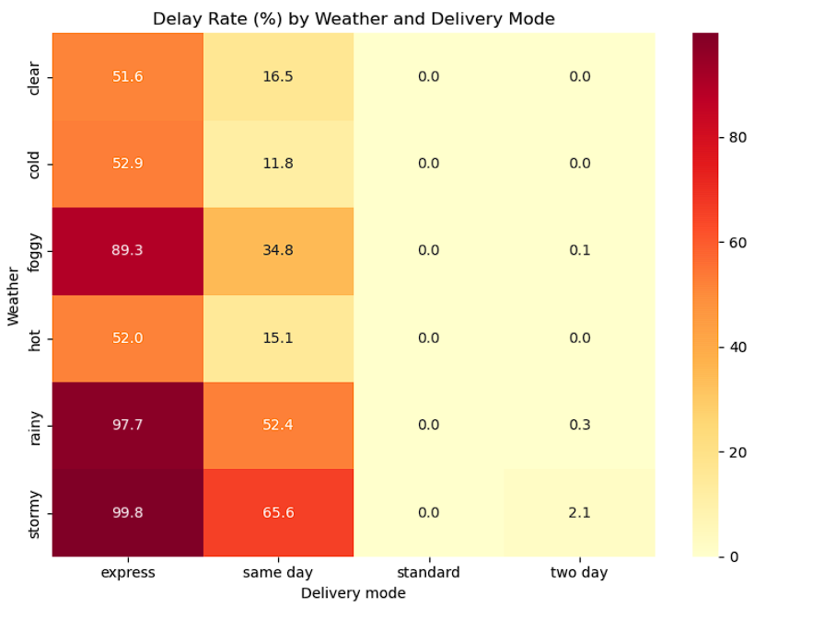
Result:
Weather | Express | Same day | Standard | Two day
Clear | 51.6% | 16.5% | 0.0% | 0.0%
Cold | 52.9% | 11.8% | 0.0% | 0.0%
Foggy | 89.3% | 34.8% | 0.0% | 0.1%
Hot | 52.0% | 15.1% | 0.0% | 0.0%
Rainy | 97.7% | 52.4% | 0.0% | 0.3%
Stormy | 99.8% | 65.6% | 0.0% | 2.1%
Insight:
- Express deliveries are late 51.6% of the time even in clear weather. Weather makes it worse (97.7% in rain and 99.8% in storms), but the base problem is the short promised time of 4.5 hours.
- Same day deliveries are the most weather-sensitive: the delay rate rises from 16.5% in clear weather to 65.6% in storms, about 4 times higher.
- Standard deliveries are never late in any weather (0.0%), and two day deliveries are late at most 2.1% of the time, in storms.
- The worst combination is express delivery in stormy weather, where almost every delivery is late (99.8%).
- The overall effect of weather on delays comes mainly through express and same day deliveries, because their promises leave little spare time.

4.6 Customer rating by delivery status
Why this chart: A bar chart compares one average across a few categories. The axis runs from 0 to 5, so the real size of the gap between the groups is not exaggerated.
rating_by_status = df.groupby("delivery_status")["delivery_rating"].agg(["mean", "count"]).round(2)
print(rating_by_status)
rating_by_status["mean"].plot(kind="bar", figsize=(7, 5), color="steelblue")
plt.title("Average Customer Rating by Delivery Status")
plt.ylabel("Average rating (out of 5)")
plt.xlabel("Delivery status")
plt.xticks(rotation=0)
plt.ylim(0, 5)
plt.show()
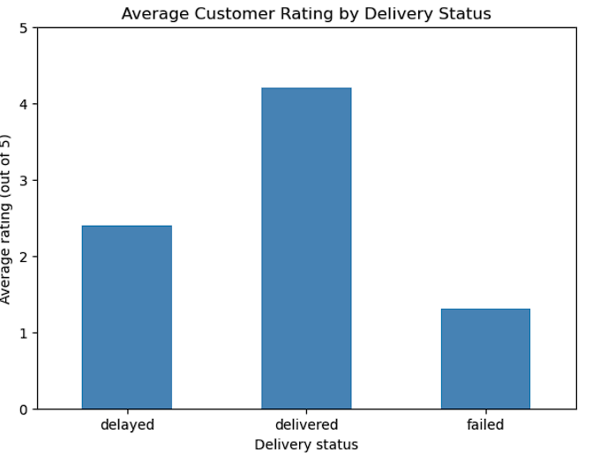
Result:
Delivery status | Average rating | Number of deliveries | Share of all deliveries
Delivered (on time) | 4.21 | 18,331 | 73.3%
Delayed | 2.40 | 5,341 | 21.4%
Failed | 1.31 | 1,328 | 5.3%
Insight:
- A delayed delivery loses 1.81 rating points compared with an on-time one (4.21 down to 2.40), and a failed delivery loses 2.90 points (down to 1.31).
- Delayed and failed deliveries together make up 6,669 of 25,000 deliveries (26.7%), which closely matches the overall delay rate of 26.7%.
- The 26.7% of unhappy customers are what keeps the overall average rating at 3.7 instead of the 4.21 that on-time deliveries get.

4.7 Delay rate by delivery partner and region
Why this chart: Bar charts sorted from lowest to highest make it easy to see whether one group stands out. Using the same style as the other charts keeps the comparison fair.
delay_partner = (df["delayed"] == "yes").groupby(df["delivery_partner"]).mean() * 100
delay_region = (df["delayed"] == "yes").groupby(df["region"]).mean() * 100
fig, axes = plt.subplots(1, 2, figsize=(14, 5))
delay_partner.sort_values().plot(kind="bar", ax=axes[0], color="steelblue")
axes[0].set_title("Delay Rate by Delivery Partner")
axes[0].set_ylabel("Delayed deliveries (%)")
axes[0].set_xlabel("")
delay_region.sort_values().plot(kind="bar", ax=axes[1], color="seagreen")
axes[1].set_title("Delay Rate by Region")
axes[1].set_ylabel("Delayed deliveries (%)")
axes[1].set_xlabel("")
plt.tight_layout()
plt.show()
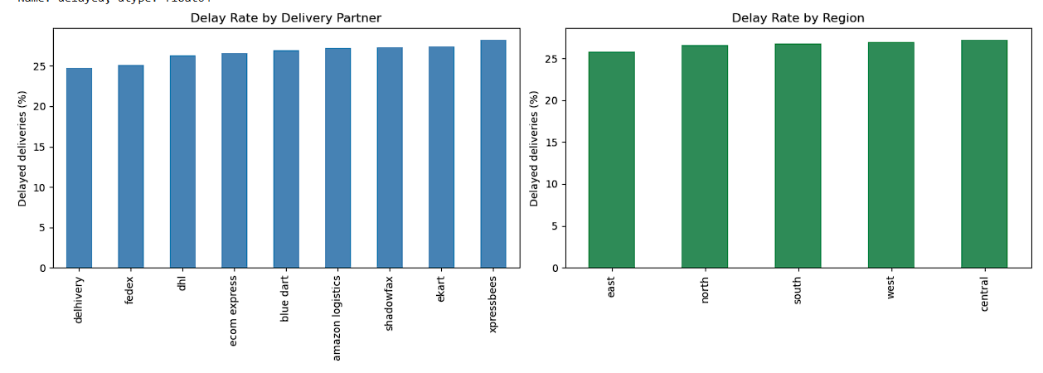
Result:
Delivery partner | Delay rate | Region | Delay rate
Delhivery | 24.8% | East | 25.8%
FedEx | 25.2% | North | 26.6%
DHL | 26.3% | South | 26.8%
Ecom Express | 26.6% | West | 26.9%
Blue Dart | 26.9% | Central | 27.3%
Amazon Logistics | 27.2%
Shadowfax | 27.3%
Ekart | 27.4%
XpressBees | 28.3%
Insight:
- The nine partners lie between 24.8% and 28.3%, a gap of only 3.5 percentage points. The five regions lie between 25.8% and 27.3%, a gap of only 1.5 points.
- Compare this with weather (16.0% to 41.4%) and delivery mode (0.0% to 73.8%), where the gaps are far larger. Partner and region are minor factors in this data.
- Changing partners or focusing on one region would not fix the delay problem.

5. Analytical Insights
Operational efficiency. The average delivery takes 6.2 hours against 13.1 hours promised, so on average the operation looks efficient. But 26.7% of deliveries are still late, and the problem is not spread evenly. It is concentrated in express (73.8% late) and same day (32.5% late) deliveries, while standard (0.0%) and two day (0.4%) are almost never late.
Cost drivers. Distance is the main cost driver, with a correlation of 0.99 with cost. Weight has a correlation of only 0.10. Costs range from ₹95.7 to ₹1,632.7 with an average of ₹864.9, and the range follows the distance range (3.6 to 297.1 km). Delivery time also rises with distance (0.69).
Bottlenecks. Three bottlenecks were found:
- Promise setting. All four delivery modes take about 6.2 hours, yet express promises 4.5 hours. The promised time is almost unrelated to the actual time (correlation 0.04).
- Weather. Delay rates rise from 17.4% in clear weather to 41.4% in storms, and for express deliveries from 51.6% to 99.8%.
- A slow tail. A small group of deliveries takes 12 to 19 hours, double the typical 6 hours.
What is not a bottleneck. Vehicle type (26.1% to 27.0%), delivery partner (24.8% to 28.3%) and region (25.8% to 27.3%) all show very small differences.
Customer impact. Delays cost customer satisfaction: the average rating falls from 4.21 for on-time deliveries to 2.40 for delayed ones and 1.31 for failed ones.

6. Recommendations
- Reset the express promise. Express is promised in 4.5 hours but takes 6.2 hours on average, and 73.8% are late. The promise should be moved closer to the real time, for example 7 hours or more, or the process should be redesigned so that express really is faster.
- Add weather buffers for express and same day. In stormy weather, 99.8% of express and 65.6% of same day deliveries are late. Extra time should be added to promises on stormy, rainy and foggy days, which are 41.4%, 37.4% and 30.3% late overall.
- Do not spend money on changing vehicles, partners or regions to fix delays. Their delay rates differ by 0.9 points (vehicles), 3.5 points (partners) and 1.5 points (regions), far less than weather or delivery mode.
- Review how deliveries are priced. Cost follows distance almost exactly (0.99) and ignores weight (0.10). The company should check whether this matches its real handling costs for heavy packages.
- Track the right KPIs. A weekly dashboard should show on-time rate by delivery mode and weather together, and the share of deliveries that take more than 12 hours, because averages hide both.
- Investigate the slow tail. The deliveries that take 12 to 19 hours should be examined further to find their cause.

7. Conclusion
The charts show that delays in this dataset come mainly from how promises are set and from bad weather, not from vehicles, partners or regions. Express and same day deliveries in rainy and stormy weather are the main problem area, and distance is the main driver of cost and time. A table of averages would have hidden these patterns, which shows why the right chart for each question matters. Delays also have a clear cost for customers, with ratings falling from 4.21 to 2.40.
Limitations. The data shows relationships, not proof of cause. For example, the link between long promised times and high ratings is likely explained by fewer late deliveries, but this was not tested. The dataset also has no shipment counts, so weight was used as the measure of shipment size.
Next step. A prediction model can use these findings to estimate which deliveries are likely to be late before they are sent, using delivery mode, weather and distance.

References
- kundanbedmutha, "Delivery Logistics Dataset (India – Multi-Partner)", Kaggle: Kaggle dataset page
- CigoTracker, "What is Delivery Data Visualization? Understanding Its Importance for Your Logistics Operations": CigoTracker glossary
- SeaRates, "Harnessing Data Visualization for Freight Efficiency": SeaRates blog
- The Entourage, "6 Real Life Scenarios Where Logistics Dashboards Optimize Supply Chains": The Entourage blog

